**Cyber Security Challenge 2019**

**TEAM CHOCOBEE**

1. Canada - Project searching MH370

STEP 1:

Find for TCP that contains python

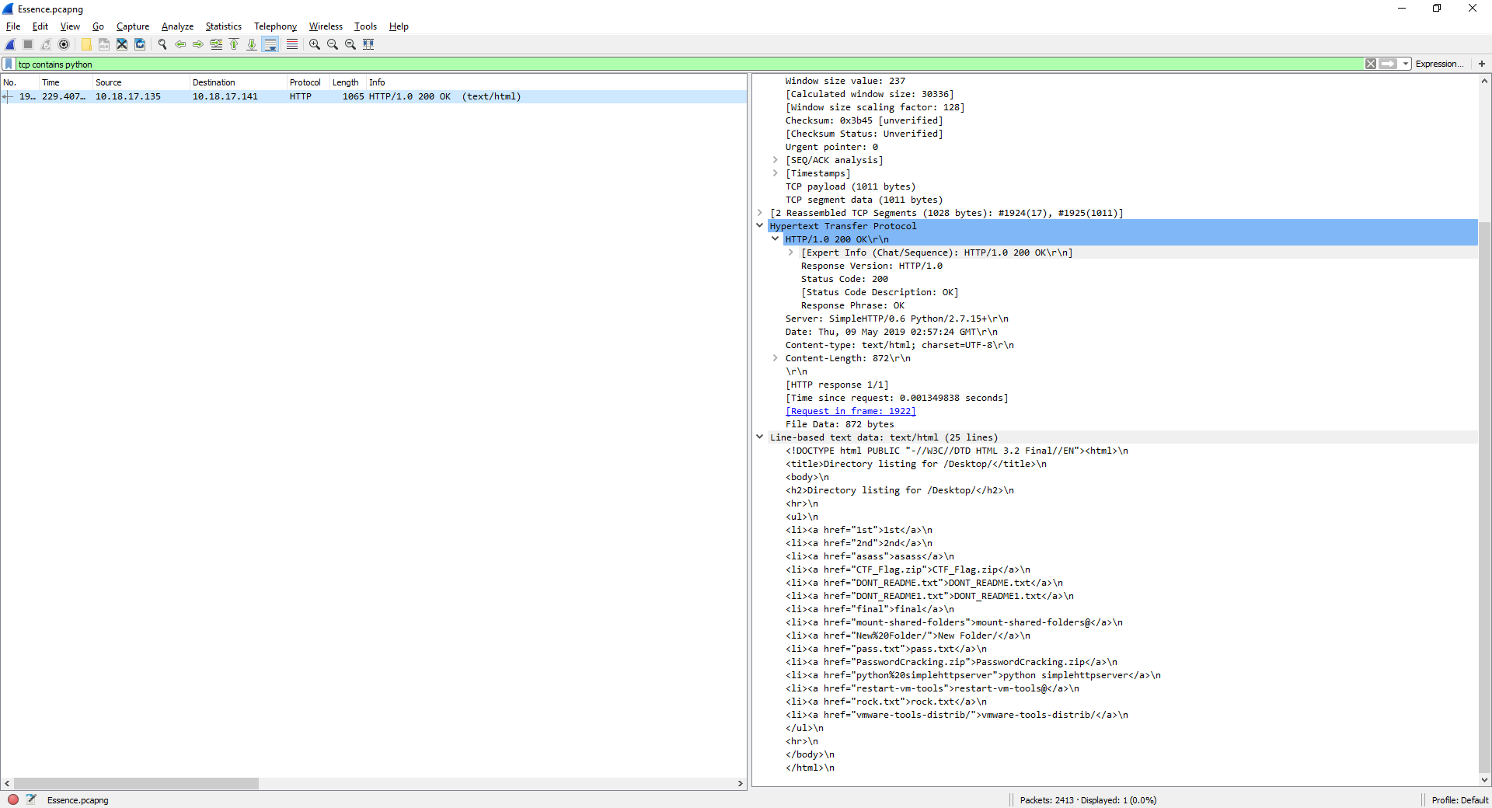

STEP 2:

From there we knew that there is a CTF_Flag.zip



STEP 3:

Follow the TCP stream and convert it to show and save data as raw

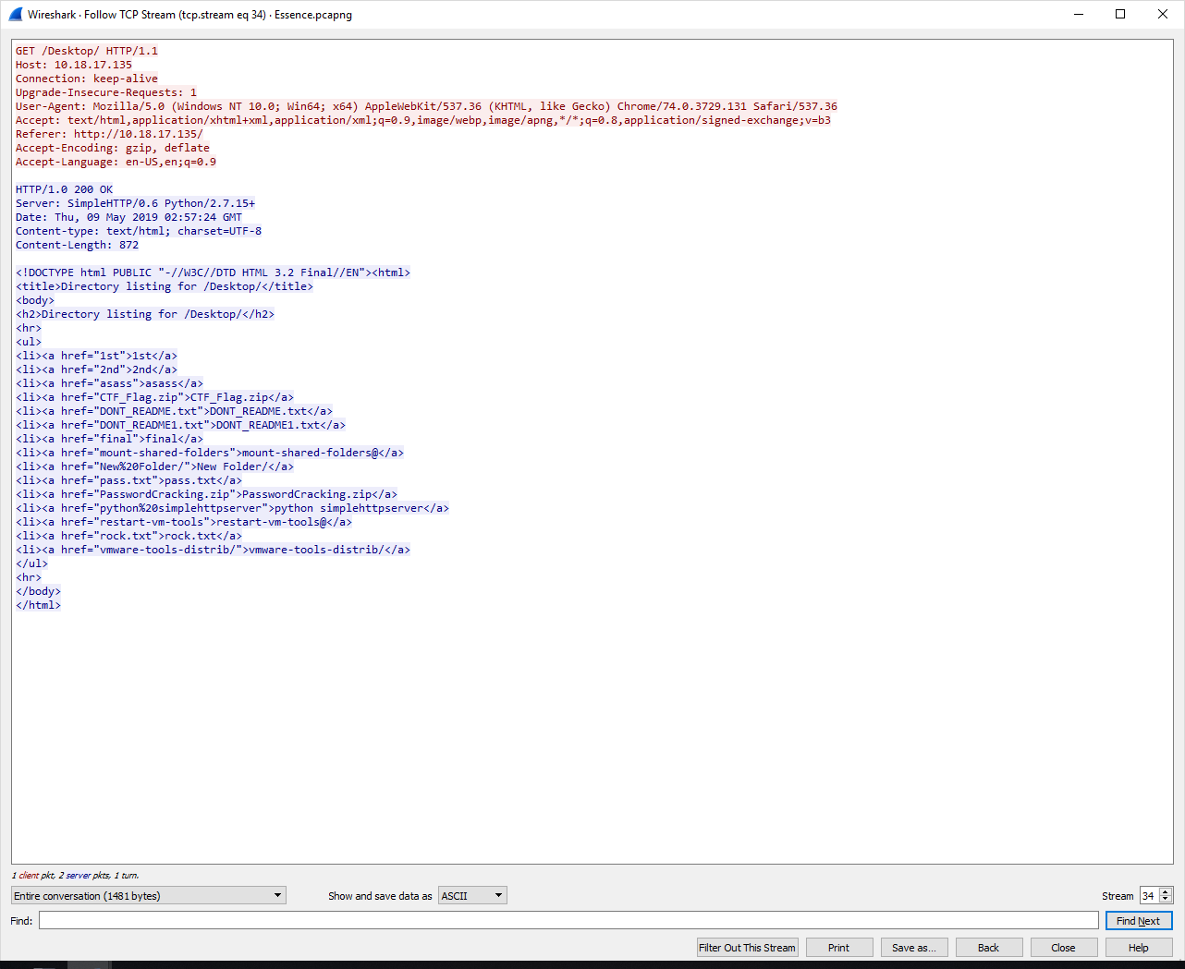

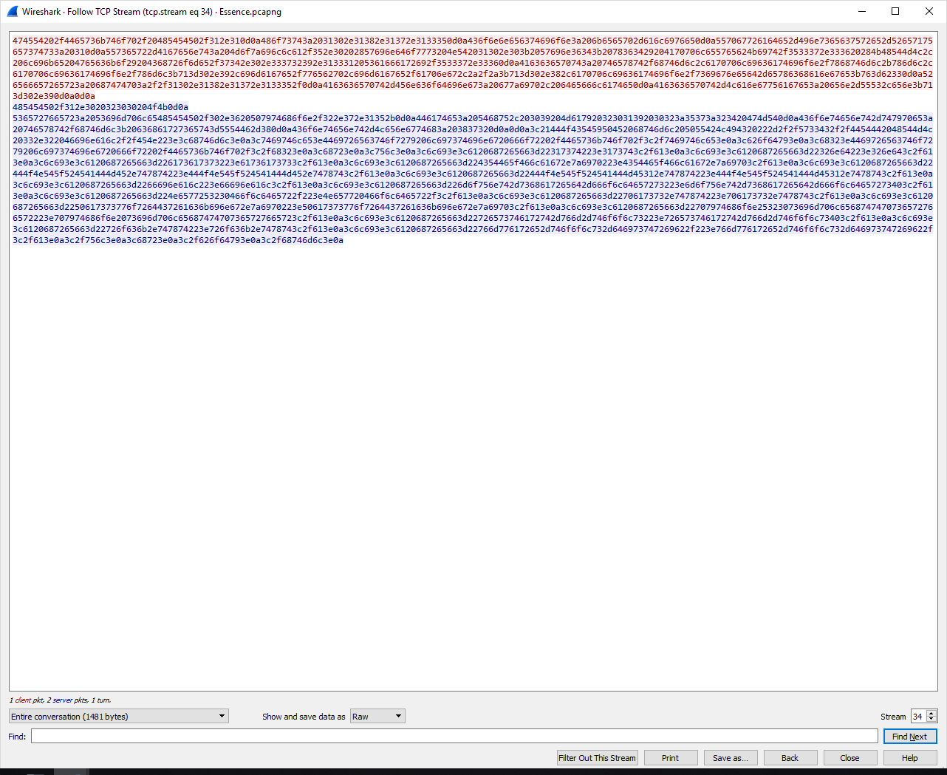

STEP 4: Save the data as firstzip

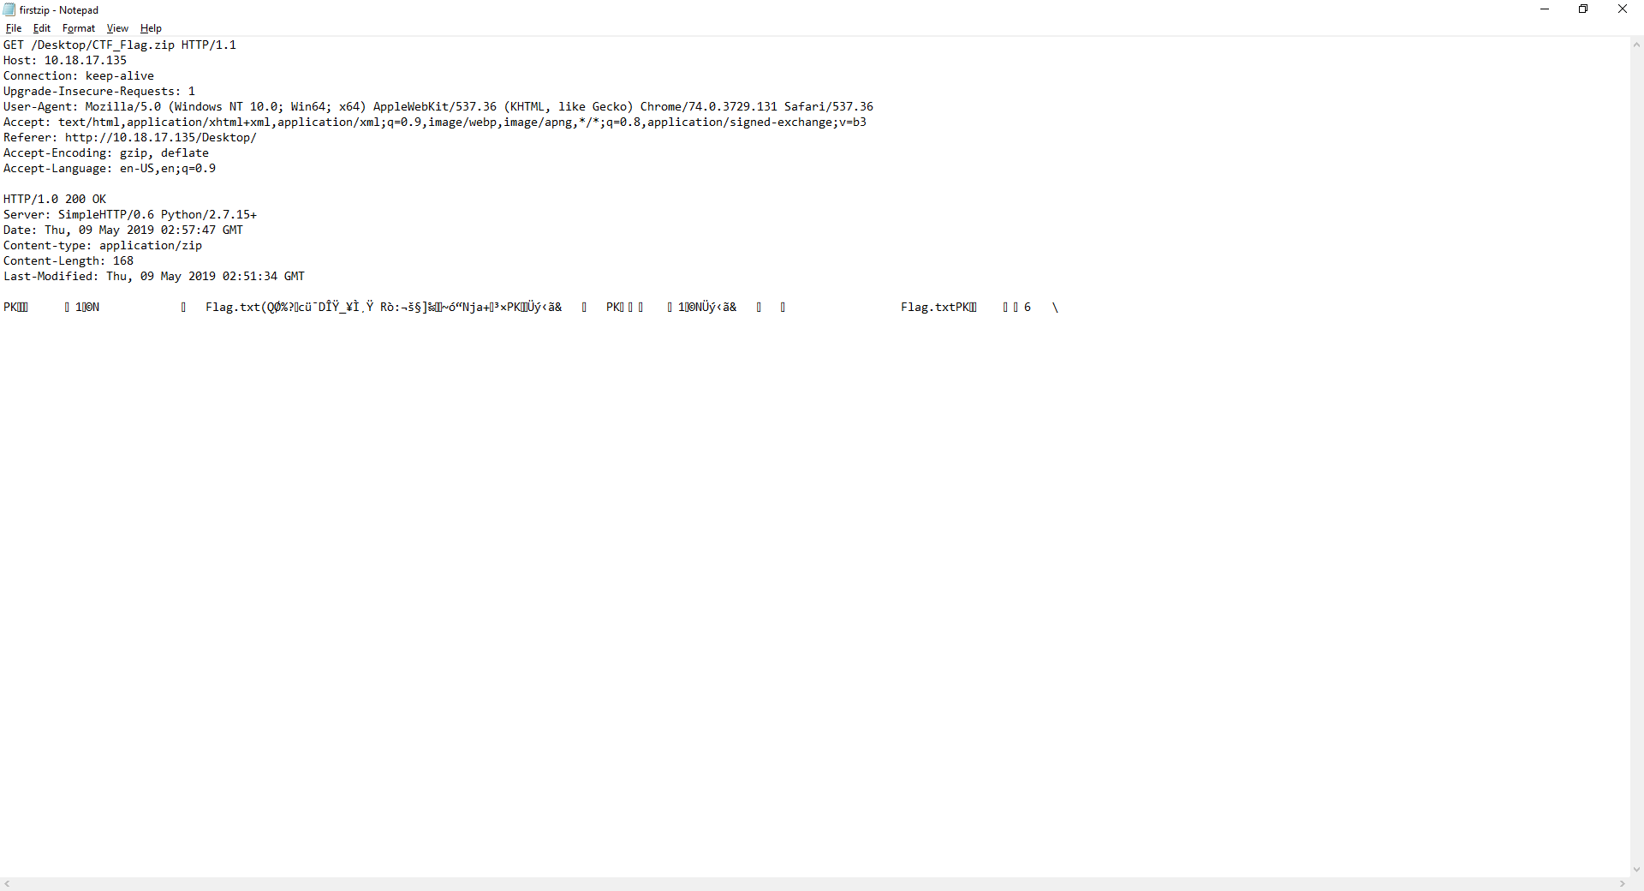

STEP 5:

Move the data to UNIX and unzip it. Then it will ask for Flag.txt password

STEP 6:

From the command TCP contains python, we also knew that there is a pass.txt



STEP 7:

Find for TCP that contains pass

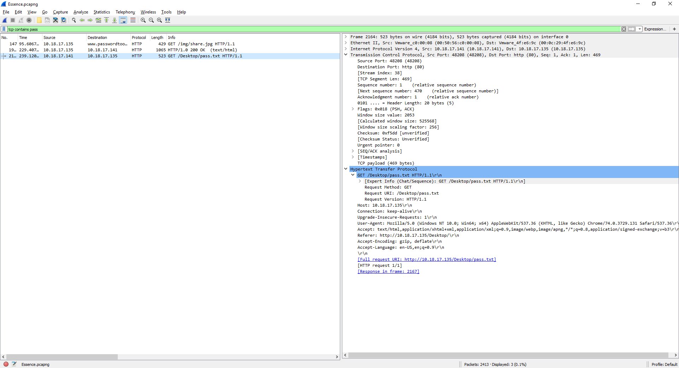

STEP 8:

Follow the TCP stream, which contains the pass “W@k@nd@_s0m3tim3s”

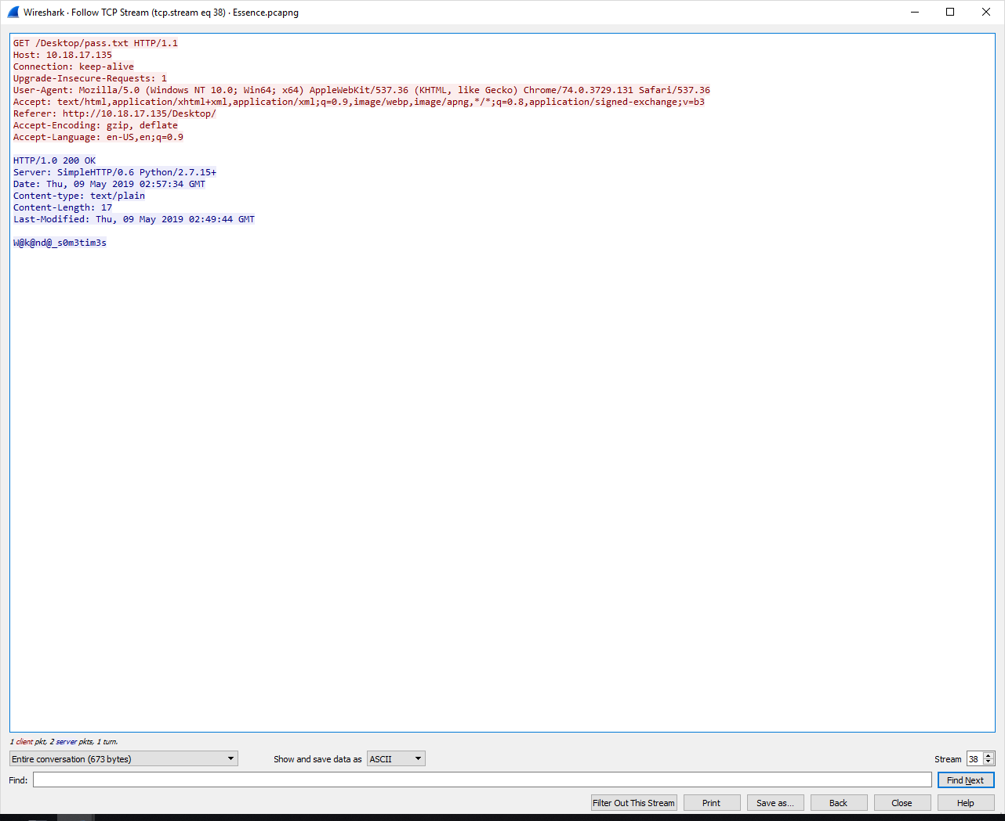

STEP 9:

Insert the pass and finally we can retrieve the flag.txt

1. Angola – Least Significant Failures

STEP 1:

We used the stegsolve.jar tool to help us

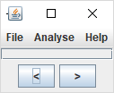

STEP 2:

We insert the Kanye.png file to the tool and find for hidden flag

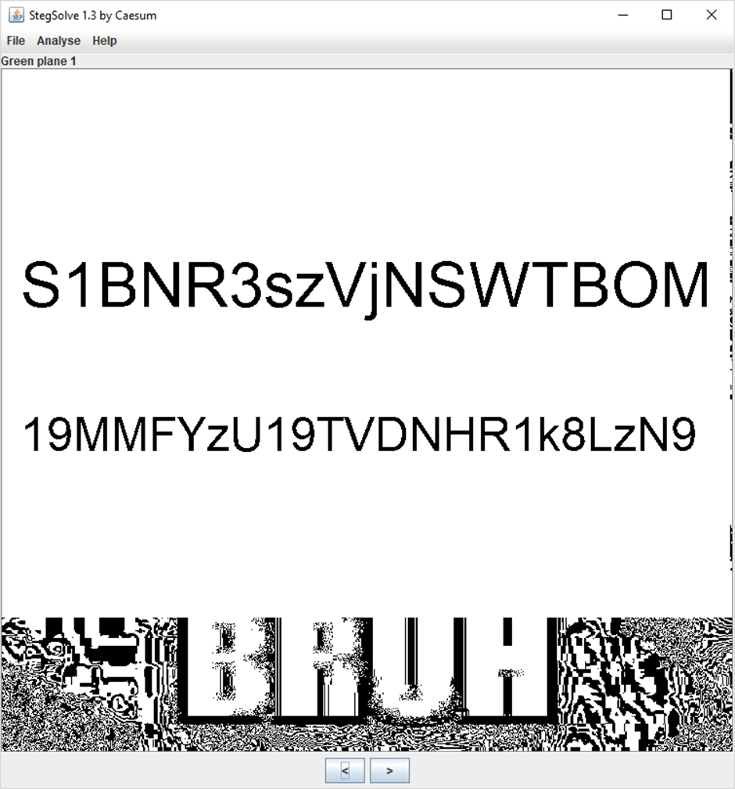

STEP 3:

We then decode the base64 text to plain text which gives us the flag: KPMG{3V3RY0N3_L0V3S_ST3GGY</3}

